Total Marks:
Obtained Marks:

LAB: Artifiical Intelligance

Lab Task # 12

Last date of Submission: Dec 18th, 2025

Submitted To: Mam Mutahra Khalid Butt
_______________________________________________________________________________________________________________________________________________________________________________________________________________________________________
Student Name: Ubaid Bin Waris
_______________________________________________________________________________________________________________________________________________________________________________________________________________________________________
Reg Number: 2212416
_______________________________________________________________________________________________________________________________________________________________________________________________________________________________________

CODE:

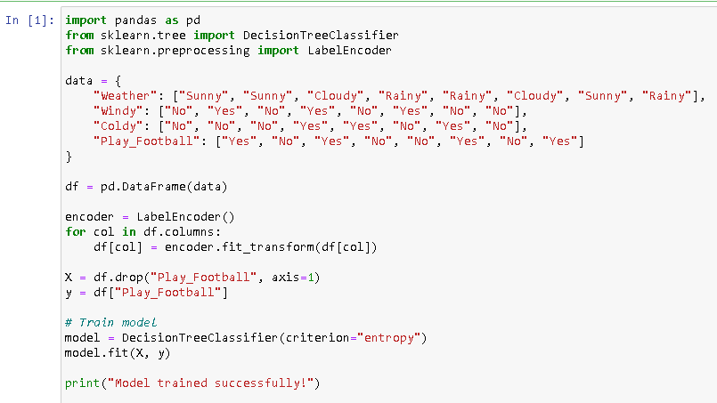
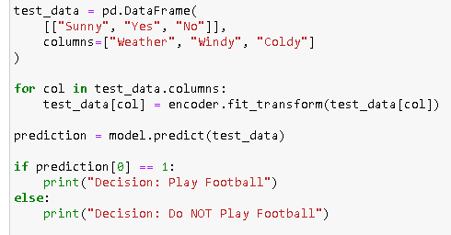

OUTPUT:

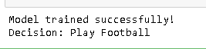

CODE:

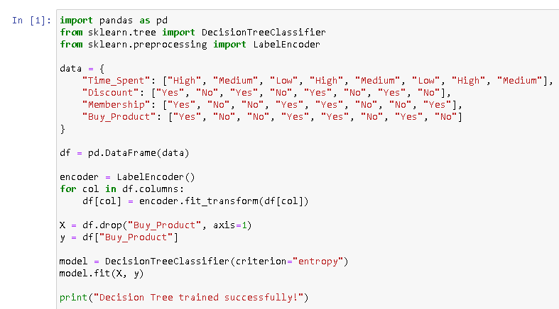

OUTPUT:

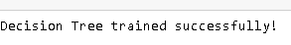

CODE:

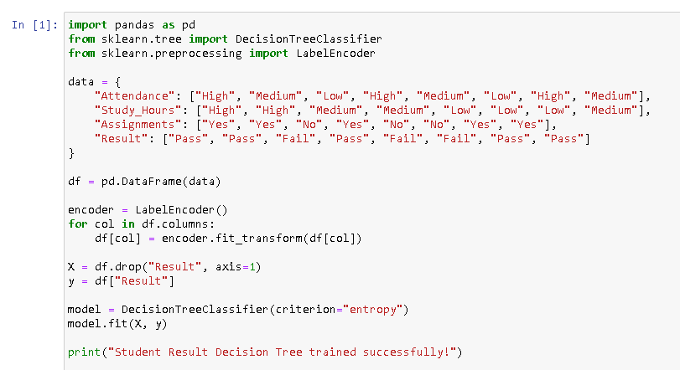

OUTPUT:

